Create Your Own Family Heritage Book!
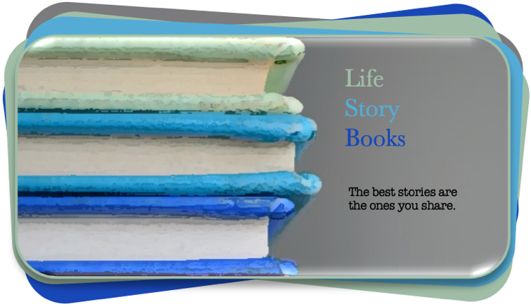
Visit: https://life-story-books.com

| Life Story Books | DIY #1 |

5 Things to Consider When Starting Work
On Your Own Family Heritage Book

- Get rid of perfect.

- What is most important?

- What defines your emotional investment?

- What sits at the center of the page?

- Do an inventory check.

Introduction: Whether you are just starting out, or if you have done a lot of family history research, one of the most important skills you can practice is to take what you have and to figure out what you need to create a compelling and engaging book that you and others will value. And this is particularly true for those parts of your family, or your family archive materials that you feel most emotionally connected to. In moments like this, it turns out that you can choose your family -specifically:

- Who, or what needs to be captured and told?
- What do you know and appreciate hat others in your family would benefit from?

The phenomenal thing about a book is that it requires you to organize your family history archive materials into a coherent structure and story (or set of stories). And this makes it lasting and shareable. Turning your family history and heritage into a book that you can share with others is a gift that your family will return to again and again throughout their lifetimes.

But, in most instances, the truth is that most of our family histories are:

- in bits and pieces of memory,
- loosely organized in dusty piles,
- or stuck on a digital ancestry site.

And the excellent family stories that do get told also deserve to be recorded. With a book, or a series of books, you can give:

- your siblings, parents, and children a more expansive sense of identity and tradition.
- the chance to connect with family in ways that is not possible otherwise.

And you can make your most important and unique family heritage:
- more permanent,
- more accessible,
- more shareable,
- a bigger part of your family’s life,
- a part of what makes your family, family, your home, home.

Family heritage books do not need to be comprehensive, or perfect, to be very valuable. To spur your emotions, my favorite examples are in the form of questions:

[Continued …]

“What does a particular family photograph mean to you that nobody else will appreciate unless you tell them?”

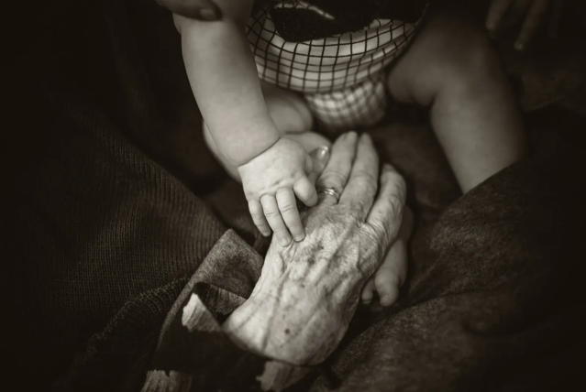 | “What does a particular family photograph mean to you that nobody else will appreciate unless you tell them?”

But, maybe even more critical are questions like this, “What do you know about your grandfather that your children will forget, if you don’t write it down for them?”

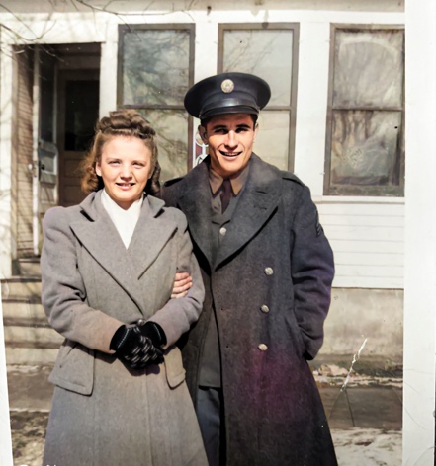 | “What do you know about your grandfather that your children will forget, if you don’t write it down for them?”

Or, maybe a family artifact is most important. You have your grandparent’s recipes in a loosely bound notebook. It is easy to photocopy the recipes for your family, but you have a history and memories of a loved one making these dishes. What stories do you have about food traditions that you should capture and share for future generations?

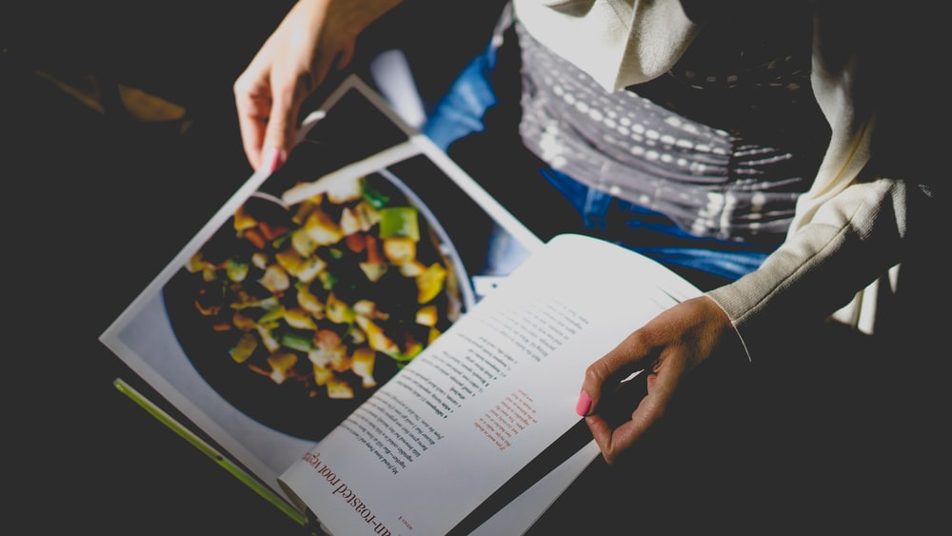 | “What do you know about your most important family recipes and traditions that you want others to know?”

Each book is unique. And so many kinds of books are possible, based on your family needs. Can you imagine how stunning it could be to have a book with your traditional family recipes, combined with short stories and memories around those dishes (and maybe even photographs of you making those dishes with family)? Or, what is another version of such a book that speaks to you?

As you consider what kind of book to make, five perspectives might help in these early stages:

1. Start by throwing perfect out the window: Throw perfectionism and the sense that something has to be comprehensive to be meaningful out of the window. Those are two things that are hard to ignore, but you should. So many critical things about families get lost, over time, because it gets put off for an imaginary time in your life when you’ll have enough time to do it “right”. Here’s a hint, that time will never arrive. You have been meaning to do this for some time. It is good that you’ve been meaning to do this. There’s no good reason to wait. So, let’s get started!

- Perfectionism.
- Comprehensive.
- When the time is right.

And here is the thing. It is easy to say “throw these things out”. But, even when you do this mentally, they will continually try to hijack your work throughout the whole process. And even after you have created a wonderful family heritage book that your family will treasure for a long time, you will still wonder, “What if …,” or “If only I had …”.

The only good family heritage book is the completed family heritage book. And the only way to accomplish that is to make peace with this advice:

“Do the best you can with what you have right now.”

There will always be temptations in this line of work, where you will want to find that lost photograph, or wait until you can find one new, important bit of information, or … . Wanting to have, or know more should be a healthy tool based on curiosity and goals, but not a barrier to progress. All anyone can do is “Do the best we can with what we have right now.” If finding something is going to take too long, abandon it (for now), so you can make the progress that is critical to accomplishing what is most important.

2. What is most important? Spend time thinking about what is, potentially, most important to you. For example, is it about:
- Honoring a particular person?
- Is it a series of family artifacts like letters and photographs,
- is it a set of family stories,
- a particular generation, or time-period in your family’s history,
- your family living in a particular place,
- your family’s story of immigrating and arriving to a new place,
- a story of a farm, or profession,
- is it related to family traditions,
- a love story of an inspiring couple in your family,
- a dramatic story with tragedy and triumph,
- is it …?

3. What defines your emotional investment? You might have several ideas in mind. Entertain those ideas. And start to reflect on why this particular topic is important. What, do you think, your emotional investment is based on? What makes this one thing, or a handful of options more important than other options?

4. Creating a “center” or a focal point … from which everything else can be organize is crucial. And it takes time and work to identify that point of focus. One way to put it is, what sits at the center of the page that is the anchor that holds everything else steady as you work? Typically, your “center” for a family heritage book is not a fact, or a thing, but an emotional connection, a sense of need and purpose, from which a story, or set of stories must be told.

5. Inventory check? As you consider these things -a core topic, your focus (or anchor) and emotional connections, there is one more thing to do at the beginning. Focus on your “inventory” or what you have in your “backpack” that will help you on this journey. Do you have the family heritage equivalent of food, water, and shelter? Or is there a core thing that you will need to find, or get to accomplish this journey?

Do you need to find that series of letters you know you have somewhere in the attic? Or, how about those photographs of your great-grandparents from their time farming in the early 1900’s? Or, that family recipe book? Or, those old newspaper articles about a relative? Or do you need to talk to, or interview a specific family member about a particular time in their life?

There are, of course, no wrong answers here. Your parameters are only defined by what you want. Where does that want come from? Where is it leading you? The most important family heritage books are the ones that help you express something that is important to you and your family.

Perhaps too, your focus fits with something like, “The Top 5 Things that Most in the U.S. Want to Know about Their Grandparents”?

1. 72% of people want to know | more stories about when their grandparents were young.

Isn’t that sweet to know, that 72% of those polled by Ancestry.com said that they want to know more stories about their grandparents when they were young!

Do you have a grandparent that you should interview? What would a list of questions be like if you asked them today? Who else in your family would be good to ask? What is preventing you from setting up that interview and asking those questions? Take out your smartphone and record your elder generation reminiscing and talking. Get their voice on tape, their laugh. And use what you capture to complement the best, old family photographs that you still have.

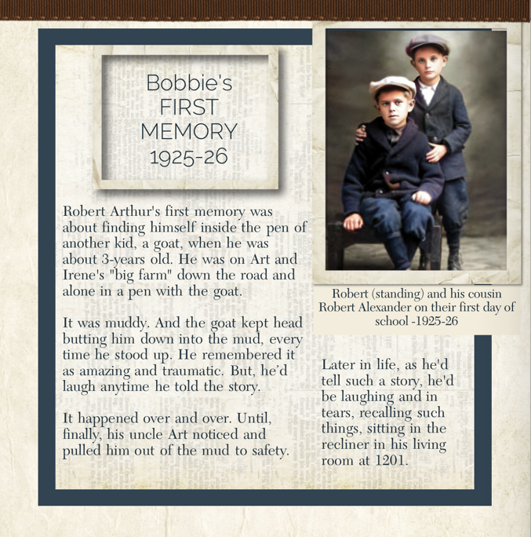 | What is preventing you from setting up that interview and asking those questions? Take out your smartphone and record your elder generation reminiscing and talking.  Get their voice on tape, their laugh.  And use what you capture to complement the best, old family photographs that you still have.

I’ll share more in a later series about a phenomenal interview technique, where you use the best old photographs you have to guide your interview(s) with loved ones. But, for now, what else did people report that they most wanted to know?

2. 62% want to know more about | their grandparents’ childhood memories.
3. 62% want to understand | where our family came from.
4. 62% want to know more about | their heritage.
5. 51% want to know | their grandparents’ life advice.

Do any of those categories fit with your own goals? They are general categories, but still good starting points from which to work. There are a whole range of other things to consider as you proceed from here, but those are for later. If you can spend time thinking about these first 4-steps, that is a great place from which to work and make progress. This is a process and do not expect certainty at the beginning. In making your own DIY family heritage book, hopefully, time is on your side. And from here, we will proceed! Are you excited! I hope so. So much is possible. So much is important! Let’s get going!

