Create Your Own Family Heritage Book!
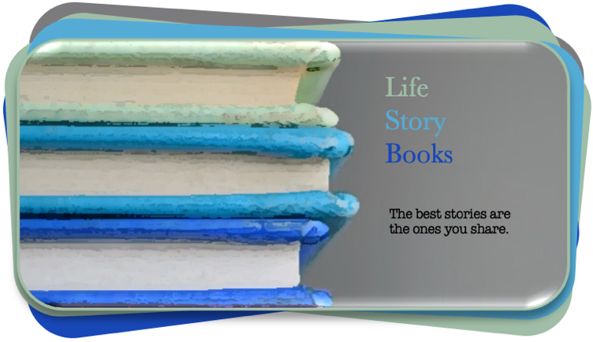
Visit: https://life-story-books.com

| Life Story Books | DIY #5 |

Visualizing You and Your Family Across Generations:
Strengthening Your Emotional Connections

- Visualizing you and your family across generations.
- Strengthening your emotional connections through visual displays

Introduction: Picking up where we left off (with DIY #4):

Let’s take our imaginary person again. Pretend that after some work and digging, our Monique can name all 8 of her family surnames up through her great-grandparents:

Family Firework Chart: Our 8 surnames back to great-grandparents.

So that Monique can categorize her family names like this:

Monique: | 1. Williams | 2. Jackson | 3. Davis | 4. Thompson |
| 5. Harris | 6. Taylor | 7. Wilson | 8. Davidson |

Surnames:  father’s side | Surnames:  mother’s side
Williams, Jackson, Davis, Thompson | Harris, Taylor, Wilson, Davidson

Now, look over your own range of surnames: … or at least as many as you know right now.

And try this exercise:

- How does each name make you feel?
- Do you have any feelings you want to write down for each, even if they are vague feelings?
- Maybe you feel a deeper connection with one family surname?
- Maybe too, you are estranged, or even concerned about the feelings that another surname evokes.

Maybe your notes look something like this -using our Monique:

- Monique Williams
Feelings: I feel very familiar with my Williams. I grew up with this surname and feel deeply connected to my father and my father’s side of the family.

- Monique Davis
Feelings: I do not know anything about my father’s mom and her Davis family. But, I really want to know more. I am not sure why my father doesn’t talk about them much.

- Monique Thompson
Feelings: I can’t tell you why, but I have known about my Thompson relatives and always been attracted to them. I feel a kinship with them, but I do not know why.

- Monique Jackson
Feelings:

- Monique Harris
Feelings:

- Monique Taylor
Feelings:

- Monique Wilson
Feelings:

- Monique Davidson
Feelings: I know that my mom’s dad had a falling out with his parents because of a tragedy and I am not sure I feel comfortable trying to learn more about my Davidson family line.

Again, don’t feel bad if you can’t name all, or even most of your great-grandparent’s surnames. Most cannot. And don’t feel bad if you can’t name many great-great-grandparents. Working between this and the last DIY, do you have a chart that looks like this yet? If not, here are those “Firework” charts:

Monique’s family:

Through her Grandparents Through her great-grandparents (mother’s side in gray).

Now, what about your family? Double-click each circle to fill them in.

How are you doing? Do you want to try to move on to your great-great grandparents? This takes quite a lot of work to accomplish for most people. Even if you have done a fair amount of family history research, or have files from others in your family who have done extensive research. Naming all 16 great-great-grandparents is still a bit of a task for most. But, starting this process identifies a proactive stance, where you can identify gaps in your knowledge to work on now, or in the future.

All 16 of your great-great grandparents? Or, at least a start?

Remember, the goal here is not just a list of names, but setting a goal to have more specific feelings, or knowledge from which to work in direct relationship not just to facts and stories alone, but your own “sense” and emotional connections. These charts, putting you at the center, prompts you to consider that “line” between “YOU” and “EACH RELATIVE” at the end. What defines that connection? Or, with some work what can come to define that connection, even if only a feeling?

What is the quality of your sense, or even your (vague) emotional connection
to each “line” connecting you to your direct descendant?

Remember too, this can be based on nothing more than a sense, a feeling. But, where possible, it might be based on a big archive of information, photographs, letters, personal relationships, etc.

If it is the former, don’t minimize vague connections, instead figure out how to nourish and build on them into the future. Because, once you have a chart like this, you can start to “play” to “shake your family tree” to see what falls out and where. Every time you shake it, you never know what might fall out. It is that act -of taking an active interest- alone that creates new opportunities.

Now, print out multiple copies of these “Family Firework” charts, or create multiple blank digital pages that you can edit. As you work, consider:

- Why do you know something about certain relatives, but nothing about others?

- What circumstances, in your life, or in your parent’s life makes your knowledge and connection to one side stronger than the others?

Key: Colors Indicating Depth of Knowledge

I know a lot about: Shade in red.

I know a bit about: Shade in orange.

I don’t know much about: Shade in blue.
Relative state of knowledge about you and your multiple family lines.

Look for the exceptions and consider, what makes them exceptional? Reflect a bit about any surprises. For example, in my life, I grew up visiting the farm where my grandfather grew up with his grandparents. So, my family had more stories about this line of our family than others. And I naturally took an interest these great-grandparents because I already had a connection to a handful of stories and had spent time on the generations-old farmland.

As you do this work, have fun! Don’t worry too much about any gaps in your knowledge. Pay attention to your feelings as you think, draw, and reflect. They are important and often fleeting. As you create visuals like this, you are only limited by your ambition and creativity.

Consider this Euro-centric ancestry, with my great-grandparents listed in the middle, and two other layers: 1. Great-great grandparents, and 2. The specific location where they were born. Obviously, you will be guided by how much information that you have, or are able to find out. But, there are many other modest versions of this that can be every bit as meaningful and valuable.

I have intentionally edited out my mother’s maiden name for security factors. Consider, though, how much information is here. It is visually engaging, informative, and contains a lot of information in a condensed design.

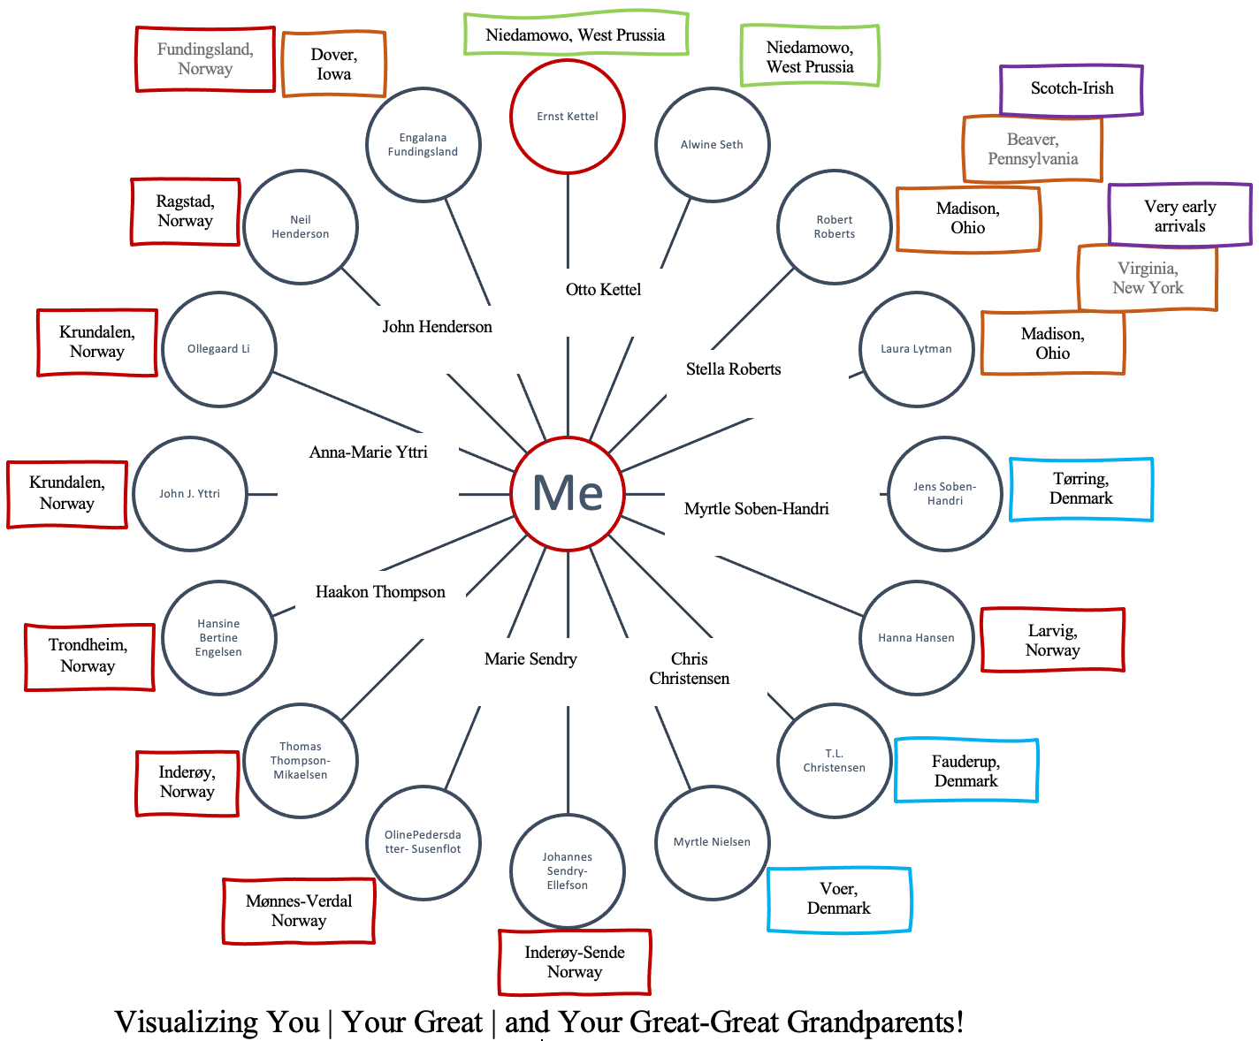

Notice too how I have not included those closer generations that I already know well, my parents and my grandparents. Those “layers” only add clutter, when I already know each of my great-grandparents. The focus here is on my priorities, specifically on learning my great-great grandparents’ lineages and names and where they were born. This offers a very compelling presentation of my heritage, with an emphasis on my geographic and cultural points of origin.

It helps, of course, to know all of this information. And, in some cases, it is impossible to find out such information. In other cases it takes patience and years of work. But, don’t let that stop you. Start filling it out, so you know exactly where your gaps in knowledge and information are at. Even with a chart like this, these are prompts for future work, such as getting to know more about those places that I’ve never heard of, like Fundingsland, Norway! That sounds made up! : ) I’ll have to find it on a map.

The other thing it might prompt is another version, where your focus is on including photographs of those relatives that you are fortunate enough to have in photos. What does a kaleidoscope of family photographs look like, extending outward, in generational-layers, from you? How might that open up new opportunities to create emotional connections by a different means? Remember, fun is key. Making your relatives accessible, visual, present, within reach, etc. can change how you feel about them, even if you aren’t learning much about them, you are still starting, or strengthening an emotional connection and, in a sense, a relationship, even with those relatives you’ve never met (especially with those relatives!).

Once you start, it can get a bit addicting! There are so many ways to play with the layers of meaning, information, and connection between you and your generations of direct relatives. Here are copies of those visuals for you to edit, or to print out. Have fun!!

Visualizing You and Your Grandparents
Use your grandmothers’ maiden names.

Edit this by double-clicking on each circle and typing in the necessary information. It will automatically re-size the font to fit.

Visualizing You and Your Great-Grandparents
Use Your Grandmothers’ Maiden Names

Edit this by double-clicking on each circle and typing in the necessary information. It will automatically re-size the font to fit.

“Family Heritage Firework”: Visualizing You | and Your Great-Great Grandparents

Edit this by double-clicking on each circle and typing in the necessary information. It will automatically re-size the font to fit.

Add more layers of information, such as places of birth, if known along the outside?

Where your x2 great grandparent was born
Great-grandparent
Double click to edit

6.5 font

“Family Heritage Firework”: Visualizing You (1) | Your Great Grandparents (8) |
and Your Great-Great Grandparents (16) |

1. Copy and paste, or move these textbox features as you fill in your great-grandparents’ names with 6.5 font / centered. Double-click the textbox if you want to get rid of the border, select “no line”. Feel free the double-click each textbox and change the size to fit your names.
Phyllis Robinson

2. Copy and paste this to add the locations of your great-great grandparent’s birth locations.
Use this textbox to type in the locations, centered / with 6.5 font.
Perth, Australia
Double-click on the textbox to change the color of the border.
Click on it to drag it to different locations.

3. Or, if you want to add a different layer of information, or a different color scheme, edit as necessary.

